Measures of Location: Third Moment

[John S Butler (TU Dublin)](https://johnsbutler.netlify.com)

# Introduction

A different aspects of a distribution of data can be summarised by the measures of location:

1. The First Moment: Middle.
2. The Second Moment: Spread.
3. **The Third Moment: Symmetry.**

All that being said, I would always recommend plotting the data first before anything else.

**A picture (histogram) is worth a thousand words.**

# Third Moment: Symmetry

## Skewness

### Definition 1:

Skewness is a measure of symmetry (or not symmetry) of a distribution. Pearson’s Coefficient of Skewness number 1 uses the mode to calculate skewness, given by the formula is:

$$sk_{1}=\frac{\overline{x}−Mode(x)}{σ}.$$

### Definition 2:

Pearson’s Coefficient of Skewness number 2 uses the median to calculate skewness, given by the formula is:

$$sk_{2}=3\frac{\overline{x}−Median(x)}{σ}$$

, where $\overline{x}$ is the average of the elements, $σ$ is the standard deviation, $Mode(x)$ is the mode of the elements and $Median(x)$ is the median of the elements.

# Interpretation of Skewness

How to interpret Skewness:

* A skewness near means the distribution is symmetric.
* A Negative skewness means the distribution is right skewed
* A Positive skewness means the distribution is left skewed

# Symmetric Example

The figure below shows a symmetric histogram of 2000 concert attendees ages observations at a good concert: 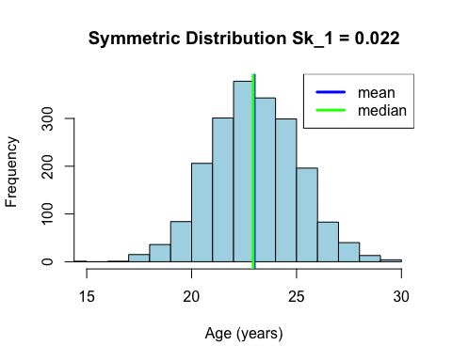 The age distribution is equally distributed around the mean, hence the skewness is more or less 0.

# Positive Skewness Example

The figure below shows a positive skewness histogram of 2000 attendees age observations at a Justin Bieber concert:

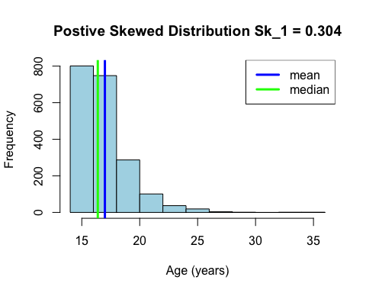

The age distribution shows that the concert attendees are mostly young, hence the skewness is positive.

## Negative Skewed Example (Age at Andre Rieu Concert)

The figure below shows a negative skewness histogram of 2000 attendees age observations at a Andre Rieu concert:

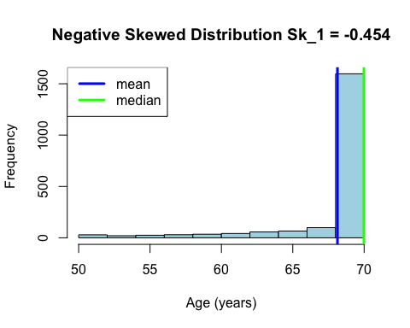 The age distribution is skewed to the right side as the concert has mostly older adults, hence the skewness is negative.

### All in one plot

## `stat_bin()` using `bins = 30`. Pick better value with `binwidth`.  
## `stat_bin()` using `bins = 30`. Pick better value with `binwidth`.  
## `stat_bin()` using `bins = 30`. Pick better value with `binwidth`.

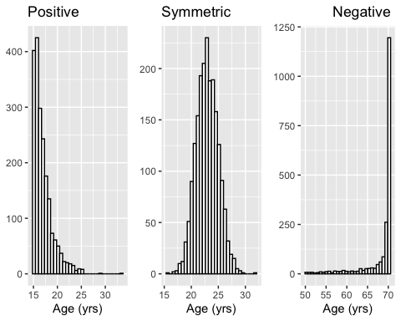

## Bi-modal distribution

The figure below shows a histogram of 3000 attendees age observations at a Wiggles concert: 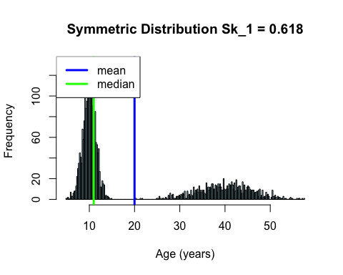

The distribution is bimodal as there are 2000 excited children with 1000 parents wear earplugs, the skewness is positive but this is misleading.